Cathy Xu Final Project Documentation

# 1-index.html page:

The html page contains following code in the head area of the page.

<meta charset="utf-8">

<meta name="viewport" content="width=device-width, initial-scale=1.0">

<title>Cathy Xu Portfolio</title>

<!--CSS Files Start-->

<link rel="stylesheet" href="css/bootstrap.css">

<link rel="stylesheet" href="css/style.css">

<!--CSS Files End-->

<!--Montserrat Font Google Api Start-->

<link href='https://fonts.googleapis.com/css?family=Montserrat' rel='stylesheet'>

<!--Montserrat Font Google Api End-->

<!--Javascript Files Start-->

<!--Bootstrap JS requires jquery Library-->

<script src="js/jquery-3.2.1.js"></script>

<script src="js/bootstrap.js"></script>

<script src="js/script.js"></script>

<!--Javascript File End-->

The html page contains following sections in body area of the page

1. Navigation bar
2. Introduction Section
3. Projects Section
4. About Section
5. Skills Section
6. Footer Section
7. Hire Me Popup Section
8. Resume Popup Section
9. Project View Popup Section

The last three sections’ default style is set to “display:none”. And it will appear on popup only.

## 1-Navigation Bar:

It has two divs

1. Header (That contains image and name and a toggle button that will appear on small devices.)
2. Navigation bar (All three navigation links.)

It’s all style is done using bootstrap classes. Some styling is done for overriding the bootstrap style like color, font-size and margins, padding etc.

On Large Screens:



On Small Screens:

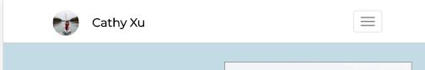

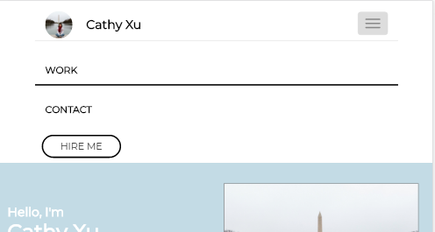

## 2-Introduction Section:

It contains two main divs:

1. One contains Name, Linkedin contact, and buttons.
2. And second contains image.

Both are styled using bootstrap classes like “col-md-6” for dividing the grid into half.

And buttons will be used for popup windows for hire me and resume section.

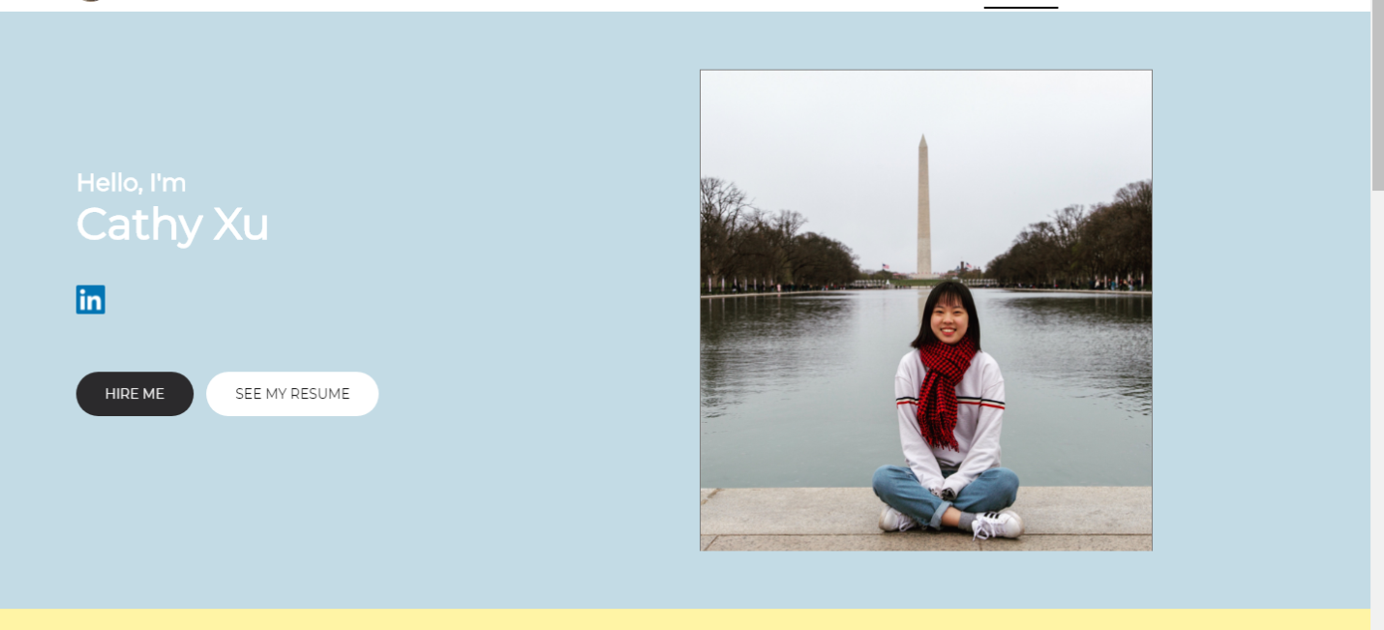

## 

## 3-Projects Section

This section contains projects information and there are total 6 divs for projects that contains project image and title and are each div is closed into anchor tag so that on click its details popup window appear.

These are also stylized using bootstrap columns classes like “col-lg-4”. As grid contains total 12 columns so these are divided into three parts in large screens.

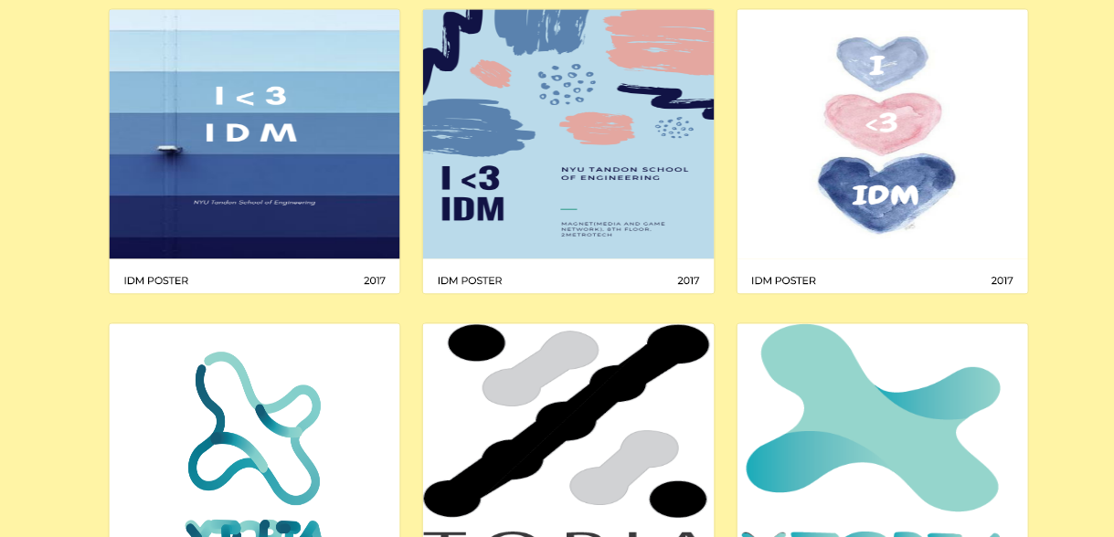

## 4-About Section

It contains my information and two buttons. This section is covering the full grid, padding and margins are added for indentation.

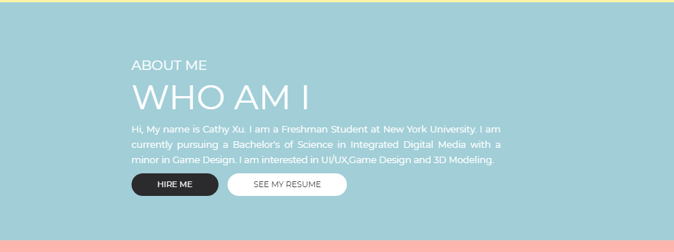

## 5-Skills Section

This section is also styled by dividing grid into three parts. That contains image and title.

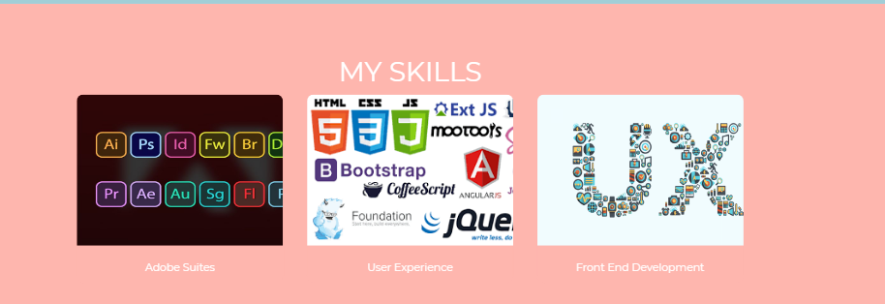

## 6-Footer Section

This section Contains copyright line and navbar.

## 7-Hire Me Popup Section

This section contains one main div as modal-overlay for hire me window. Inner div is content div that have all other things like close button, headings, paragraphs, and form etc.

## 8-Resume Pop up Section

This section contains one main div as modal-overlay for resume window. Inner div is content div that have all other things like close button, headings, paragraphs, and buttons etc.

It is also styled using bootstrap classes. It has three buttons over it.

1. Download (On click it will download the resume in pdf format that is in resume folder of your project directory.)
2. Print (On click it will open the print window from where you can download it)
3. Hire me (It will open hire me popup over it.)

## 9-Project View Popup Section

This section contains one main div as modal-overlay for Project View Window. Inner div is content div that have all other things like close headings, paragraphs, image etc.

All images are included in this section but there property is “display:none;”. So, each one will be displayed on project click.

Likewise poster and project description is also there and will be opened on click.

# 2-Style.css

1. Printing page Settings: (It contains Settings and style of the resume as it will appear on the print, as buttons will be hidden on print page.)
2. Media Queries: (It contains styles of some elements on different screen resolutions so that each element appears properly on all size of screens.)

# 3-Script.js

It contains four functions:

1. Hire me popup (Popup the hire me section)
2. Resume popup (Popup the resume section)
3. Project view popup (Popup the Project view)
4. Printing function (Print the resume)